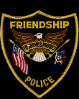
TOWN OF FRIENDSHIP POLICE DEPARTMENT
In an effort to better serve our community, its members and the local business’s, we are asking for some help. We are asking members of our community to fill out surveys pertaining to our Police Department. These surveys can be found at the clerk’s office or see any board member. Please have these surveys returned to the clerk’s office or you can drop them off at our court mailbox located outside of our office by April 30th 2021. Thank you for assisting us, we look forward to hearing from you!

